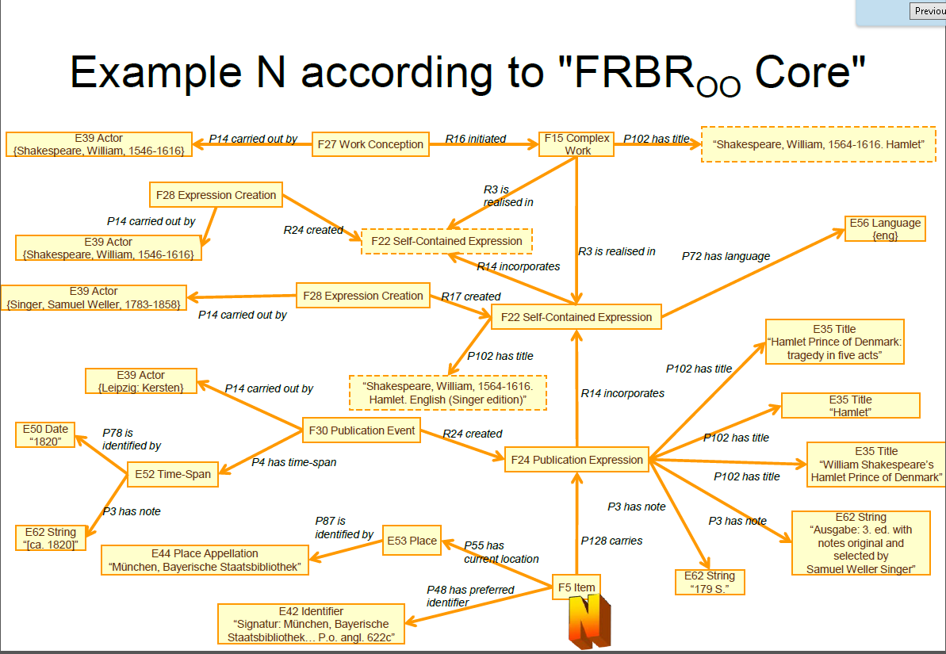

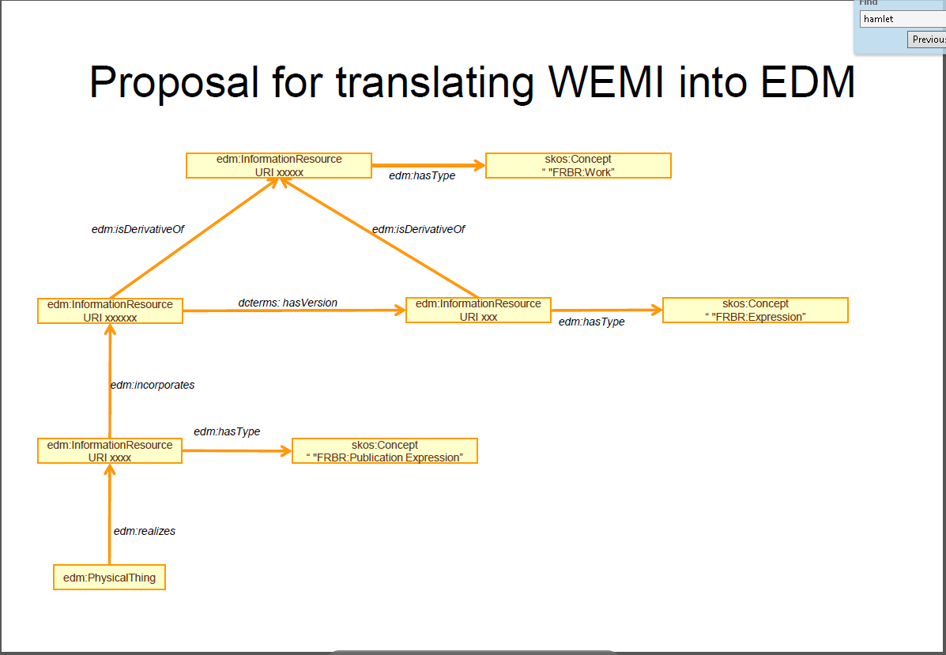

https://pro.europeana.eu/files/Europeana_Professional/EuropeanaTech/EuropeanaTech_taskforces/EDM_FRBRoo/TaskfoApplication%20Profile%20EDM-FRBRoo.pdf